David Vega

CS-230: 1-5 Assignment: UML Diagrams

Professor Tim Hogg

09/04/2022

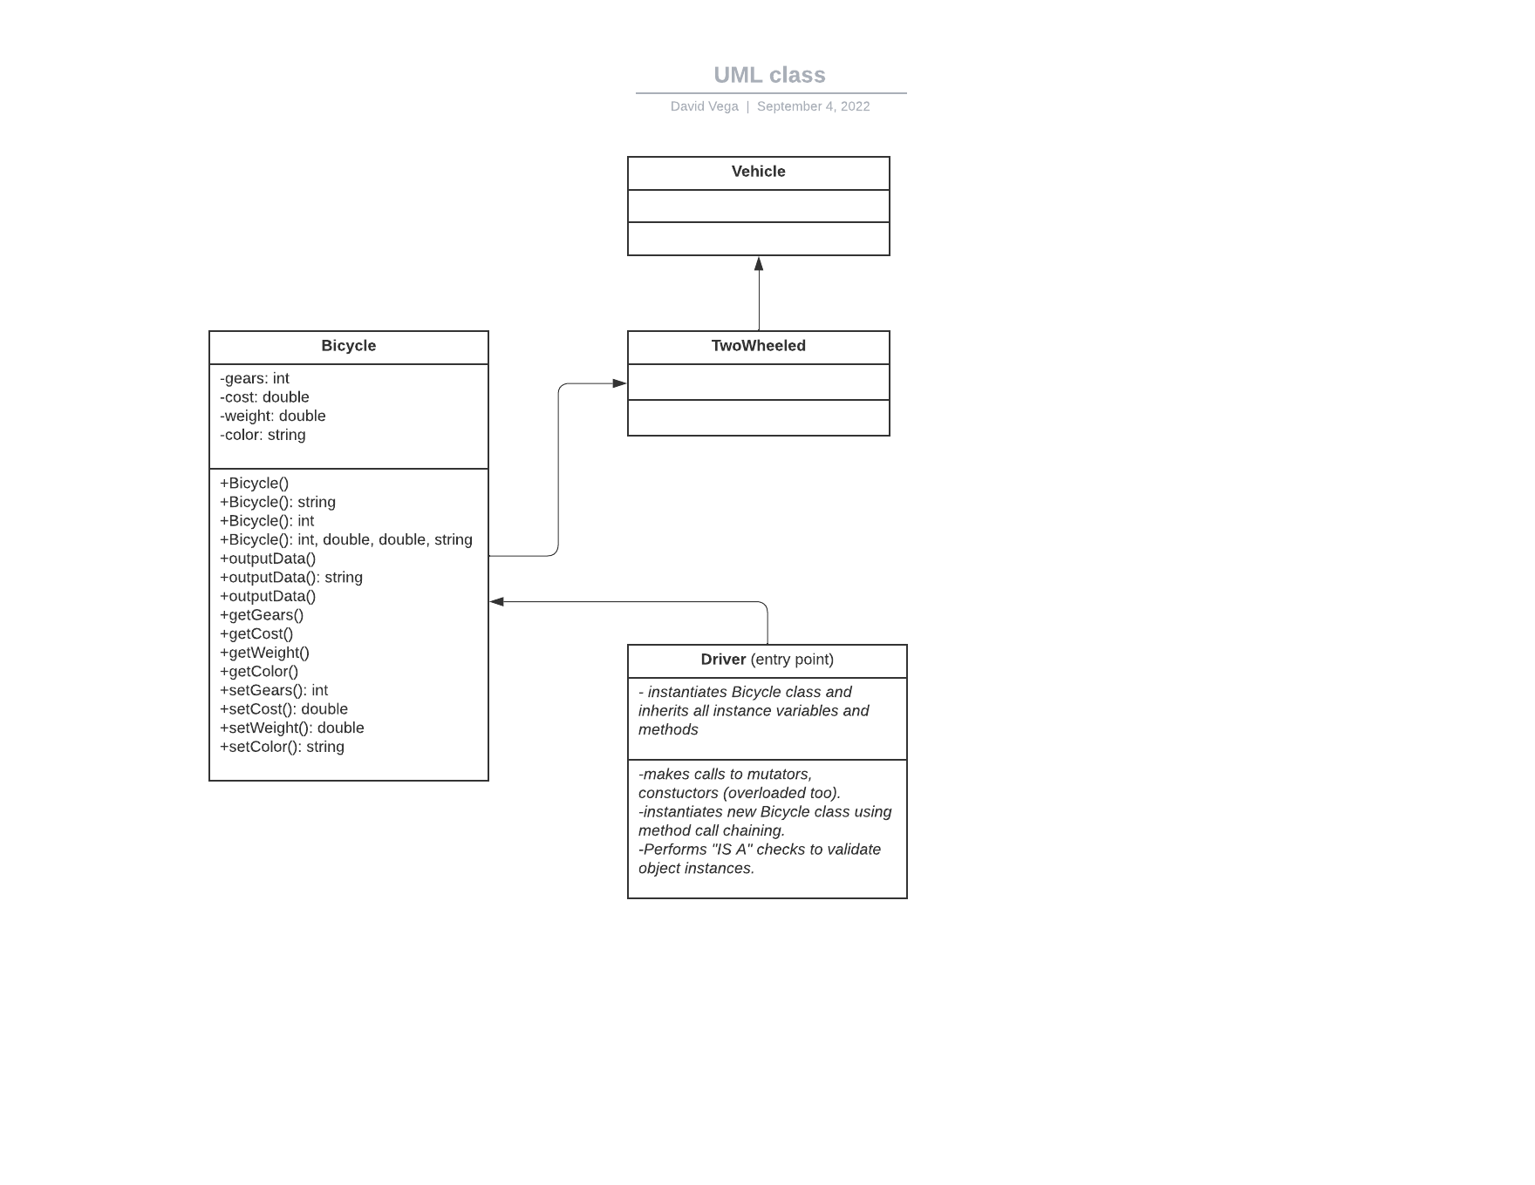

Above is the single classification of an object that inherits from supertypes. In this diagram the main entry point of the program is the Driver class. This class can instantiate Bicycle class as many times as it wants. It can contain logic to obtain data from the Bicycle class as well as mutate it by utilizing the “getters” and “setters” of the Bicycle class. The Driver class inherits from the Bicycle class which contains all of the logic needed to get and set the data. The Bicycle class inherits from the TwoWheeled class and the TwoWheeled class inherits from the Vehicle class. In a real-world scenario the Vehicle class and TwoWheeled class would have instance variables and methods with respect to their own object structure.